Agriculture and ICT

Agriculture is the basis of life. It has been practiced from the dawn of human civilization. With the advancement of Science and technology, world is becoming a Global village and agriculture is turning to an attractive industry. Information Communication technology (ICT) is also a major key factor to make all this possible.

Agriculture is the sector of high risk and uncertainties and most vulnerable for the threats of climate change. Though it has to fed the increasing population pressure from the decreasing (due to use of productive land for the shelter and urbanization of growing population) productive land and availability of the natural resources. ICTs such as the Internet, networked computers, mobile phones, and smart phones are the latest in a long line of technologies (the newspaper, telegraph, telephone, radio, and television) that support risk management practices by collecting, processing, distributing, and exchanging information. (World Bank 2007).ICT play an important role in addressing challenges and uplifting the livelihoods of the farmers.

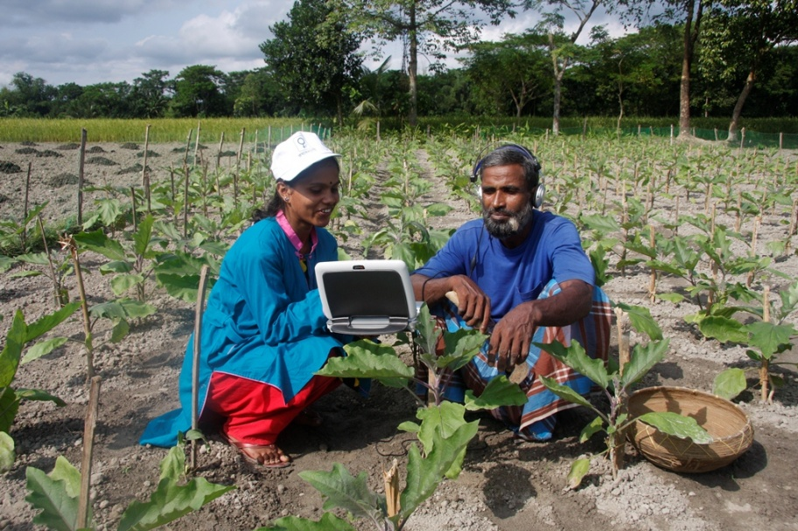

(Photo Source: CGIAR)

Enhancing agricultural production by increasing the efficiency, productivity and sustainability of small scale farms is an area where ICT can make a significant contribution. Farming involves risks and uncertainties, with farmers facing many threats from poor soils, drought, erosion and pests. Key improvements stem from information about pest and disease control, especially early warning systems, new varieties, new ways to optimize production and regulations for quality control. Awareness of up-to-date market information on prices for commodities, inputs and consumer trends can improve farmers’ livelihoods substantially and have a dramatic impact on their negotiating position. Such information is instrumental in making decisions about future crops and commodities and about the best time and place to sell and buy goods. Many NGOs are also working for the market access, for example SMILES-Nepal is providing farmers information through mobile-SMS about the disease pests control and also about Market price to sell at higher demand and to get the greater market price of farm commodities in Sindhuli district of Nepal.

ICT also play major role in capacity-building and empowerment of farmers, farmer communities and farmer organizations/groups and better represent their constituencies when negotiating input and output prices, land claims, resource rights and infrastructure projects. ICT enables rural communities to interact with other stakeholders, thus reducing social isolation. It widens the perspective of local communities in terms of national or global developments, opens up new business opportunities and allows easier contact with friends and relatives. Combining old and new media is most successful, such as videos of good practices, rural Dramas, TV and radio broadcasts, which all provide input for local innovation and motivation , for example a TV program **Sajha Sawal** by BBC media group showed some successful farmers of the country which brings the great impacts on the youth to attract in agriculture. One modal Wireless communication system Started by Ramon Magsaysay Award Winner, **Mahabir Pun,** initially in three districts (Myagdi, Kaski, and Parbat) of Nepal has also shown the utility and implications for the agriculture. Farmers can search for Labors, commodities, farm products, goat, Buffalos and also can purchase and exchange them through wireless internet. ICT used by local communities is subject to rapid change. Use of mobile phones has seen an enormous increase in recent years, especially in rural areas in Nepal. For rural exchange of products and labor and also for the Planning at different levels from farmers to ministries, ICT is increasingly being used.It is generally accepted that information to sustain and increase agricultural production is spread over different agencies, notably farmers, universities, research institutes, extension services, commercial enterprises, and non-governmental organizations (NGOs). Local Indigenous knowledge on good practices and lessons learned about innovations is generally not captured. Information should be presented in an appropriate format in order to be effectively used by rural communities. Messages through videos in local languages have proved to be effective.

The different phases of agriculture are cultivation, purchasing of inputs, fertilization, irrigation, disease pest management, harvesting,  [packaging](http://en.wikipedia.org/wiki/Packaging), [food preservation](http://en.wikipedia.org/wiki/Food_preservation), [food processing](http://en.wikipedia.org/wiki/Food_processing)/value addition, [quality management](http://en.wikipedia.org/wiki/Quality_management), [food safety](http://en.wikipedia.org/wiki/Food_safety), [food storage](http://en.wikipedia.org/wiki/Food_storage), and [food marketing](http://en.wikipedia.org/wiki/Food_marketing). All stakeholders of agriculture industry need information and knowledge about these phases to manage them efficiently. Any system applied for getting information and knowledge for making decisions in any industry should deliver accurate, complete, concise information in time or on time. The main focus of this article is to show the picture how the achievements of IT can be applied in Agriculture sector and its development in the developing country like Nepal. Other main applications of ICT in Agriculture sector are listed below:

●[Global Positioning System](http://en.wikipedia.org/wiki/ICT_in_agriculture#Global_Positioning_System) (GPS):

In agriculture, the use of the [Global Positioning System](http://en.wikipedia.org/wiki/Global_Positioning_System) provides benefits in [geo-fencing](http://en.wikipedia.org/wiki/Geofencing), [map-making](http://en.wikipedia.org/wiki/Map_making) and [surveying](http://en.wikipedia.org/wiki/Surveying). GPS receivers dropped in price over the years, making it more popular for civilian use. With the use of GPS, civilians can produce simple yet highly accurate digitized map without the help of a professional [cartographer](http://en.wikipedia.org/wiki/Cartographer).

●[Geographic information systems](http://en.wikipedia.org/wiki/ICT_in_agriculture#Geographic_information_systems) (GIS):

[Geographic information system](http://en.wikipedia.org/wiki/Geographic_information_system)/s, are extensively used in agriculture, especially in [precision farming](http://en.wikipedia.org/wiki/Precision_agriculture). Land is mapped digitally, and pertinent geodetic data such as topography and contours are combined with other statistical data for easier analysis of the soil. GIS is used in decision making such as what to plant and where to plant using historical data.

[●E-learning](http://en.wikipedia.org/wiki/ICT_in_agriculture#E-learning)

[●E-commerce](http://en.wikipedia.org/wiki/ICT_in_agriculture#E-commerce)

[●Agricultural resources and services management](http://en.wikipedia.org/wiki/ICT_in_agriculture#Agricultural_resources_and_services_management)

[●Computer-aided manufacturing](http://en.wikipedia.org/wiki/ICT_in_agriculture#Computer-aided_manufacturing),[Computer-aided design](http://en.wikipedia.org/wiki/ICT_in_agriculture#Computer-aided_design)

●[Office automation](http://en.wikipedia.org/wiki/ICT_in_agriculture#Office_automation)

Recently in Nepal, some apps like ‘ICT for Agriculture’ (award winner app of Ncell App Camp 2014), ‘Smart Krishi’ etc are developed for the literate youths and entrepreneurs to give the reliable information of the agriculture sector for promoting Agribusiness and to attract the youth in agriculture. Group of ten students of IAAS (Institute of Agriculture and Animal Science), Paklihawa Campus, Rupandehi are also trying to focus the need and essence of ICT in agriculture sector for both the agriculture students and farmers to enhance their skills and knowledge through training entitled ‘ICT4AG Handprint Challenge’ which is funded by South Asia Youth Environment Network (SAYEN). In this way, different personnel from the different walks of life are involved in the development of ICT for promoting and supporting Agriculture, which is the main occupation of Nepalese people, by utilizing her climatic diversities and regulating the Youth Drainage.